**Computer Organization**

**Tutorial 8 to 10**

**Solution 8:** 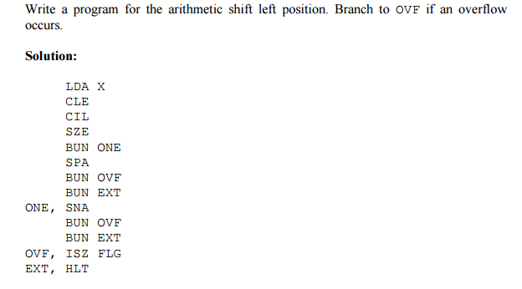

**Solution 9:** Write an assembly level program to multiply two numbers using booth algorithm,

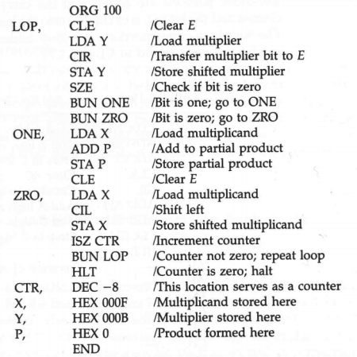

**Solution 10:** Write an assembly level program for division operation

LXI H, 5000

MOV B, M ;Get the dividend in B - reg.

MVI C, 00 ;Clear C - reg for quotient

INX H ;Increment HL pair of registers

MOV A, M ;Get the divisor in A - reg

NEXT: CMP B ;Compare A - reg with register B.

JC LOOP ;Jump on carry to LOOP

SUB B ;Subtract A - reg from B - reg.

INR C ;Increment content of register C.

JMP NEXT ;Jump to NEXT

LOOP: STA 5002 ;Store the remainder in Memory

MOV A, C ;Move Content of C - Reg to A - Reg

STA 5003 ;Store the quotient in memory

HLT ;Terminate the program.